**Fraud Detection System Using Machine Learning - Project Plan Document**

# Introduction

This project marks the 16-week effort to design and implement a reliable, fraud detection system for financial firms using machine learning[1]. This project plan describes the systematic steps for making a machine learning system that can identify fraud with an accuracy of over 95% and limit false positives under 2%.

The project consists of co-related steps: data prep, making the model, system integration and deployment, paying close care to how tasks depend on each other and available resources[1]. A team of four will use a detailed breakdown of work, deal with risks ahead of time and handle all changes properly.

With this document, we define what needs to be done, how projects will be tracked and the plans for managing risks and system configurations, ensuring we meet the organization’s requirements and standards.

# Project Scope Statement

## Project Objectives

Our goal is to create a smart fraud detection system that utilizes modern machine learning workflows to identify transactions that have a high likelihood of being fraudulent. The focus will be on optimizing the accuracy of our system while minimizing false positives, since having many false positives can make it equally if not more dangerous to the business. We will aim to have real-time analysis capabilities, allowing the organization to respond to suspicious activity as it develops while also still satisfying the user experience of normal transactions.

## Project Deliverables

The solution provided by the project will consist of several main elements necessary for detecting fraud. Random Forest, Gradient Boosting and Neural Networks will be combined by the main machine learning model to ensure as much accuracy as possible in identification. The engine automatically processes tens of thousands of transactions per second[2], minimizing problems within the transaction workflows. The system will have a main screen for seeing how fraud is unfolding, important metrics of the system and collective controls. Besides, detailed records concerning the system’s structure, its API details, guides for users and how to service and update it will also be offered.

## Project Scope Boundaries

Machine learning models, infrastructure for real-time processing, user interface components and integration APIs all form part of the project scope. Credit card and online payment fraud detection will be the main focus for the system, aided by analysis of user actions, transaction trends and spotting unusual activity[2]. But the scope does not include things like physical security, compliance with regulations beyond using technology, modifying payment gateways for third parties and assisting with ongoing operations after the first launch.

## Success Criteria

Success will be measured by quantifiable metrics of performance, including achieving a fraud detection accuracy rate greater than 95%, and false positive rates less than 2%. The system can process in real-time with the response times under 500 milliseconds, and demonstrate scalability for a minimum 10,000 transactions per minute without the degradation of performance.

## Assumptions and Constraints

The project considers historical transaction data for training, real-time transaction streams for testing, and stable network infrastructure for deployment. Technical constraints are compliance with data privacy regulations, integrations with existing banking systems, and external security requirements[2]. Resource constraints include team size of four people, a timeline of 16 weeks, and computing resources available through supervised learning for both model training and deployment.

# Gantt Chart - Fraud Detection System Using Machine Learning

Project Timeline: 16 Weeks (January 6, 2025 - April 28, 2025)

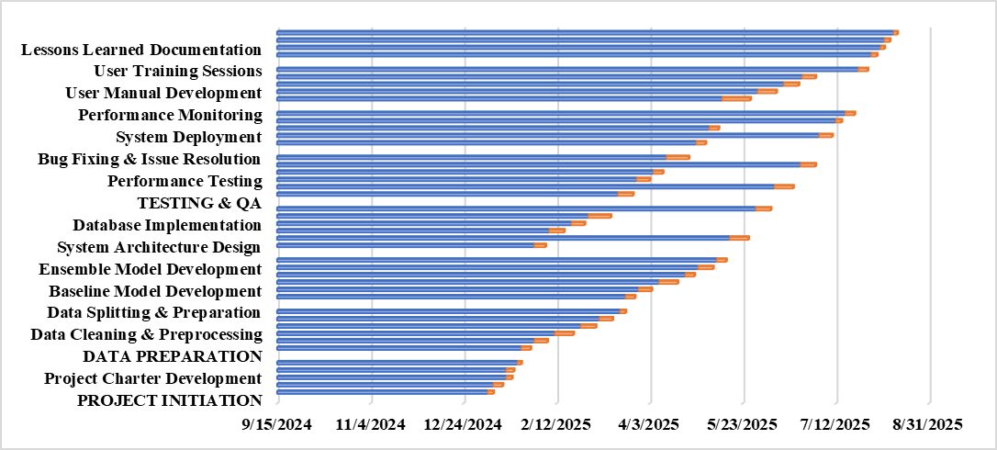

## Key Interdependencies and Critical Path

**Critical Path Activities (Total Duration: 112 Days)**

The critical path flows through the following sequence:

1. **Team Formation** → **Requirements Gathering** → **Data Preparation** → **Model Development** → **Integration Testing** → **Deployment** → **Project Closure**

**Major Dependencies:**

* **Data Preparation** cannot begin until **Requirements Gathering** is complete
* **Model Development** requires completed **Feature Engineering**
* **Integration Testing** depends on both **Model Development** and **API Development**
* **Deployment** cannot proceed without successful **User Acceptance Testing**
* **Documentation** activities run in parallel but depend on completed system components

**Resource Allocation:**

* **Week 1-2**: Project setup and planning (All team members)
* **Week 3-6**: Data preparation (Data Scientists + 1 Developer)
* **Week 7-11**: Model development (Data Scientists)
* **Week 12-14**: System integration (Developers + Data Scientists)
* **Week 15-16**: Testing, deployment, and closure (All team members)

**Risk Mitigation in Timeline:**

* **Buffer time** included in model development phase (2 days)
* **Parallel activities** where possible to reduce overall timeline
* **Early testing** integrated throughout development phases
* **Contingency plans** for critical path delays

This Gantt chart provides a comprehensive view of the project timeline, showing how activities interconnect and depend on each other, enabling effective project management and resource allocation throughout the 16-week development cycle.

# Risk and Issues Management Strategy

## Risk Identification and Assessment

There are several different risks that must be managed actively in the project. If a model fails to meet set accuracy standards, technical risks appear which could result in rebuilding the algorithms or finding and gathering more data[3]. Since poor quality training data can make the model less effective and needs thorough cleaning, these issues are very risky.

There are significant dangers from integration issues because it is necessary for banks’ legacy systems to interoperate live. Issues that arise from performance risks include uncertainty about how the product will grow and support the expected response times which may influence how the product is liked by users and how many use it[3]. Missing team members, lacking certain expertise and insufficient computing resources could postpone necessary development tasks.

Regulatory updates about fraud, changes in the market that alter what’s focused on and depending on third parties for services can all lead to external risks.

## Risk Mitigation Strategies

Risks are reduced in development through planned and thorough testing, the use of several sets of algorithms and having clear standards with strategies for addressing performance shortcomings[3]. We take care of data quality issues by triple-checking the data, using different sources and processing each sample of data thoroughly.

Eliminating integration risks calls for working with involved parties from the beginning, creating prototypes to check if solutions work together and doing the integration in stages so that each new system can be tested separately[4]. Early efforts in development cover load testing, designing for scalability and putting in place approaches for monitoring performance.

Issues related to resources are handled by offering staff extra training, identifying those with needed skills from the outside and finding ways to allocate staff as needed. Authorities supervise external risks, information from experts is shared and solutions are planned regularly.

## Issue Management Process

It allows project managers to clearly recognize, log and close issues that arise during the project. According to their importance, issues are classified as critical for immediate attention, high-priority issues requiring 24-hour solution, medium-priority issues set for resolving within a week and low-priority issues handled as part of standard development work[4].

Setting out how challenges should be handled allows the team to respond fast to urgent issues and not lose their place in the project[4]. Joining forces in regular issue review meetings allows for partners to collaborate and revise how resources are used.

# Change Request Management Process

## Change Control Framework

The process of dealing with change requests makes sure that project adjustments are assessed in a controlled way and are implemented without delaying the project deadline. A regular template records change descriptions, business reasons, impact evaluations and resources demanded for each change request.

The team sitting on the change control board decides on changes to the project’s scope, resource allocation and schedule[4]. The criteria for change evaluation have to do with meeting the project goals, ensuring enough resources are available, timing effects and considering the dangers to project success.

## Change Request Workflow

Change requests have a structured process that starts with a formal submission and an initial review process. The impact analysis completed included details such as technical feasibility, resource requirements, impact on project timeline, and impact on other project activities[5]. The stakeholder review process ensured that the change was evaluated from multiple perspectives, at a minimum: technical, business, and resources management.

The approval process defines authority levels based on the size of the change and its scope of impact. For example, minor changes may be approved through an expedited review process by the designated project managers, while major changes will invoke a full stakeholder review process with a formal approval process[5]. The planning of the implementation follows standard protocols to incorporate changes systematically with minimum disruption to other ongoing activity.

## Change Documentation and Communication

When change documentation is thorough, both the project’s past and future guidance can be found in one place. All modification requests, their results and how they are implemented are included in change logs for audit trail use. The system helps all those involved get updates about the implemented choices and their estimated dates for launching[5].

Having version control integrated means that changes are logged and managed in configuration systems, so the system remains secure and can go back to a previous version when required[5].

# Conclusion

This project plan provides a formalized structure for developing an innovative fraud detection system using technology-enabled machine learning tools. The structured process includes formal scope definition, detailed work breakdown, progressive risk management, and formal change management processes. The project team will develop a fraud detection solution that meets the organizational intent and quality standards and the project's timelines through proper planning, execution, and monitoring. Appropriate configuration management and version control processes provide monitoring of systematic progress of the work in development and project integrity in all project phases.

# References

[1]Dhananjay Kalbande, P. Prabhu, A. Gharat, and T. Rajabally, “A Fraud Detection System Using Machine Learning,” *International Conference on Computing, Communication and Networking Technologies*, Jul. 2021, doi: <https://doi.org/10.1109/icccnt51525.2021.9580102>.

[2]T. K. Dang, T. C. Tran, L. M. Tuan, and M. V. Tiep, “Machine Learning Based on Resampling Approaches and Deep Reinforcement Learning for Credit Card Fraud Detection Systems,” *Applied Sciences*, vol. 11, no. 21, p. 10004, Oct. 2021, doi: <https://doi.org/10.3390/app112110004>.

[3]J. Femila Roseline, G. Naidu, V. Samuthira Pandi, S. Alamelu alias Rajasree, and Dr. N. Mageswari, “Autonomous credit card fraud detection using machine learning approach☆,” *Computers and Electrical Engineering*, vol. 102, p. 108132, Sep. 2022, doi: <https://doi.org/10.1016/j.compeleceng.2022.108132>.

[4]A. Ali, “Financial Fraud Detection Based on Machine Learning: A Systematic Literature Review,” *Applied Sciences*, vol. 12, no. 19, 2022, doi: <https://doi.org/10.3390/app12199637>.

[5]A. Diro, N. Chilamkurti, V.-D. Nguyen, and W. Heyne, “A Comprehensive Study of Anomaly Detection Schemes in IoT Networks Using Machine Learning Algorithms,” *Sensors*, vol. 21, no. 24, p. 8320, Dec. 2021, doi: <https://doi.org/10.3390/s21248320>.